**Decision trees**

**Trần Đăng Khoa – B2014925 – M04**

1) Given dataset Golf with 4 attributes Outlook, Temp, Humidity, Windy and an attribute Play (class).

|  |  |  |  |  |
| --- | --- | --- | --- | --- |
| **Outlook** | **Temperature** | **Humidity** | **Windy** | **Class** |
| sunny | 85 | 85 | false | Don't Play |
| sunny | 80 | 90 | true | Don't Play |
| overcast | 83 | 78 | false | Play |
| rain | 70 | 96 | false | Play |
| rain | 68 | 80 | false | Play |
| rain | 65 | 70 | true | Don't Play |
| overcast | 64 | 65 | true | Play |
| sunny | 72 | 95 | false | Don't Play |
| sunny | 69 | 70 | false | Play |
| rain | 75 | 80 | false | Play |
| sunny | 75 | 70 | true | Play |
| overcast | 72 | 90 | true | Play |
| overcast | 81 | 75 | false | Play |
| rain | 71 | 80 | true | Don't Play |

- How to build the decision tree model fro classifying the dataset

Start by determining the root of the tree and the class column:

Step 1: Determine the Root of the Tree.

Step 2: Calculate Entropy for The Classes.

Step 3: Calculate Entropy After Split for Each Attribute.

Step 4: Calculate Information Gain for each split.

Step 5: Perform the Split.

Step 6: Perform Further Splits.

Step 7: Complete the Decision Tree.

- How many inductive rules are there in the decision tree model

Three of them represent very different approaches.

1. OneR learns rules from a single feature. OneR is characterized by its

simplicity, interpretability and its use as a benchmark.

2. Sequential covering is a general procedure that iteratively learns rules and

removes the data points that are covered by the new rule. This procedure is

used by many rule learning algorithms.

3. Bayesian Rule Lists combine pre-mined frequent patterns into a decision list

using Bayesian statistics. Using pre-mined patterns is a common approach

used by many rule learning algorithms.

- Use the decision tree model to classify 3 examples as follows:

***- Outlook:***

* “sunny” [2yes, 3no]= entropy(2/5,3/5) = -2/5log(2/5) – 3/5log(3/5) = 0.971
* “overcast” [4 yes, 0 no] = 0
* “rainy” [3 yes, 2 no] = entropy (3/5, 2/5) = -3/5log(3/5) – 2/5log(2/5) = 0.971
* Inpurity (outlook) = (5/14) * 0.971 + (4/14)*0 + (5/14)* 0.971 = 0.693

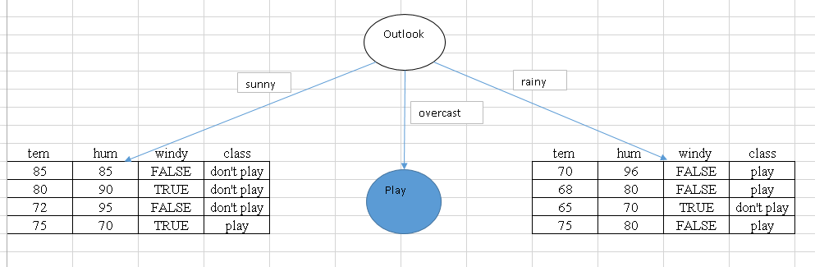

**Sunny:**

*Tem (>70 and <=70)*

“ >70” [1 play ; 3 don’t play] => entropy (1/4 ; 3/4 ) = 1

“<=70” [1 play; 0 don’t play] => entropy (1/1 ; 0/1 ) = 0

* Impurity = 4/5* entropy (1/4 ; 3/4 ) + 1/5 * entropy (1/1; 0/1 ) = 0.8

*Hum ( >75 and <= 75)*

“>75” [0 Play; 3 Don’t play] => Entropy (0/3; 3/3) = 0

“<=75” [2 Play; 0 Don’t play] => Entropy (2/2; 0/2) = 0

⇨ Impurity = 4/5*Entropy (1/4; 3/4) + 1/5*Entropy (1/1; 0/1) = 0

*Windy ( False and True)*

“False” [1 Play; 2 Don’t play] => Entropy (1/3; 2/3) = 1

“True” [1 Play; 1 Don’t play] => Entropy (1/2; 1/2) = 1

⇨ Impurity = 3/5*Entropy (1/3; 2/3) + 2/5*Entropy (1/2; 1/2) = 0,95

**Rain:**

*Tem ( >70 and <=70)*

“>70” [1 Play; 1 Don’t play] => Entropy (1/2; 1/2) = 1

“<=70” [2 Play; 1 Don’t play] => Entropy (2/3; 1/3) = 1

⇨ Impurity = 4/5*Entropy (1/4; 3/4) + 1/5*Entropy (1/1; 0/1) = 0.95

*Hum ( >75 and <=75)*

“>75” [3 Play; 1 Don’t play] => Entropy (3/4; 1/4) = 1

“<=75” [0 Play; 1 Don’t play] => Entropy (0/1; 1/1) = 0

⇨ Impurity = 4/5*Entropy (1/4; 3/4) + 1/5*Entropy (1/1; 0/1) = 0.8

*Windy ( False and True)*

“False” [3 Play; 0 Don’t play] => Entropy (3/3; 0/3) = 0

“True” [0 Play; 2 Don’t play] => Entropy (0/2; 2/2) = 0

***⇨ Impurity = 3/5*Entropy (3/3; 0/3) + 2/5*Entropy (0/2; 2/2) = 0***

**Decision tree model**

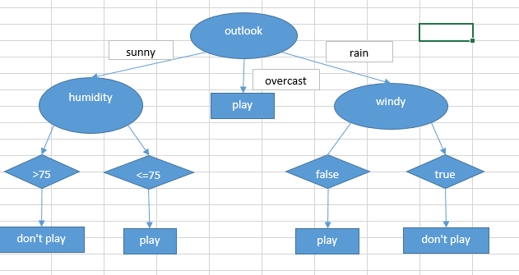

* **Result**

|  |  |  |  |  |
| --- | --- | --- | --- | --- |
| Outlook | Temperature | Humidity | Windy | Class |
| Overcast | 63 | 70 | FALSE | Play |
| Rainy | 73 | 90 | TRUE | Don’t Play |
| Sunny | 70 | 73 | TRUE | Pay |

2) Implement the program using DecisionTreeClassifier in scikit-learn library. The program requires

2 parameters:

- file name of trainset

- file name of testset

The program reports the classification results (accuracy, confusion matrix) for 5 datasets:

- Iris (.trn: trainset, .tst: testset)

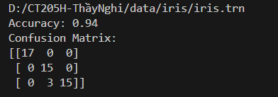

- Optics (.trn: trainset, .tst: testset)

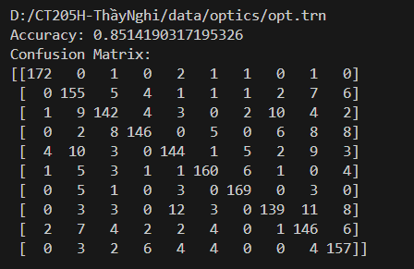

- Letter (.trn: trainset, .tst: testset)

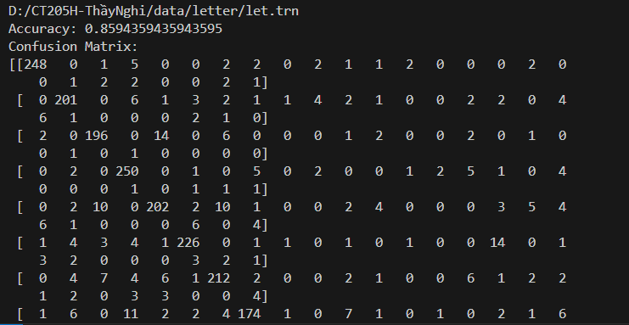

- Leukemia (.trn: trainset, .tst: testset)

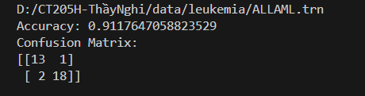

- Fp (.trn: trainset, .tst: testset)

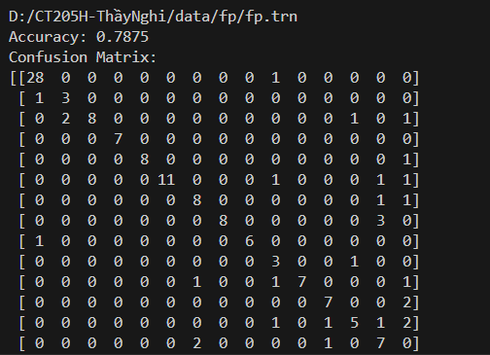

3) Why ensemble-based models improve the classification correctness of any single tree model?

Ensemble methods are ideal for reducing the variance in models, thereby increasing

the accuracy of predictions. The variance is eliminated when multiple models are combined

to form a single prediction that is chosen from all other possible predictions from the

combined models